

Lab Journal: 01
Date: 01/30/2026

Student : Lotfullah Muslimwal
Enrollment : 01-131232-039

Department of Software Engineering

Bahria University, Islamabad

Artificial Intelligence - Lab (Spring-2026)
Teacher: ENGR. SAAD MAZHAR Khan

Task No: | Task Wise Marks |  | Documentation Marks |  | Total Marks  (20)
 | Assigned | Obtained | Assigned | Obtained
1 | 3 |  | 5
2 | 3
3 | 3
4 | 3
5 | 3

Comments:

Signature

Python Installation and basic code

Task 1: Installing the python
Screenshot
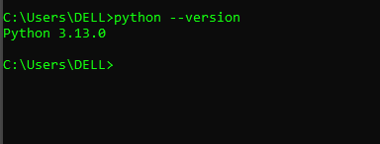
Task 2: Make a Simple Grade Calculator in Python
Code: GitHub Link
Screenshot
